**Assignment - 2**

**CSS**

**1. Use HTML and CSS to perform the following operation –**

1. **Use any heading tag to display “Cascading Style sheet”. Use inline   
   CSS to change the text colour, background colour.**
2. **Use a paragraph tag to add some text content about CSS. Use   
   internal CSS to justify the text, increase the font size. Use id   
   selector to perform the solution.**
3. **Add an image to the html page. Use external CSS along with class   
   selector to resize the image and add a blue colour border.**
4. **Use universal selector to remove the default margin and padding of   
   all HTML element. Also change the font family of the whole   
   document.**

**CODE : q1.html**

<!-- Name : uttam kumjar jena

Sic : 23mmci80 -->

<!DOCTYPE html>

<html lang="en">

<head>

<meta charset="UTF-8">

<meta name="viewport" content="width=device-width, initial-scale=1.0">

<title>First Question</title>

<link rel="stylesheet" href="./q1.css">

<style>

#para{

font-size: 32px;

text-align: justify;

}

</style>

</head>

<body>

<h1 style="color:white; background-color: grey;">Hello World!!</h1>

<p id="para">Lorem ipsum dolor sit amet consectetur adipisicing elit. Animi, error libero in adipisci, unde ea vitae saepe et itaque cum consequuntur officia? Aut ut suscipit numquam ab cum, quo ducimus ipsa, dolorum provident vel, rerum sapiente! Explicabo ipsa officiis vel molestiae amet iusto nesciunt, suscipit cumque nobis odit quaerat delectus hic fugit iste excepturi facilis? Ducimus accusamus sapiente ipsam? Quo voluptas mollitia fugiat modi atque, repellendus harum tenetur cupiditate, corrupti, enim nostrum inventore impedit nihil nam. Exercitationem, aperiam. Laboriosam, molestiae!</p>

<img class="bike" src="A2_1.jpg" alt="">

</body>

</html>

**EXTERNAL CSS FILE : q1.css**

*{

margin: 0;

padding: 0;

font-family: Cambria, Cochin, Georgia, Times, 'Times New Roman', serif;

}

.bike{

height: 400px;

width: 600px;

border: 2px dashed blue;

}

**OUTPUT:**

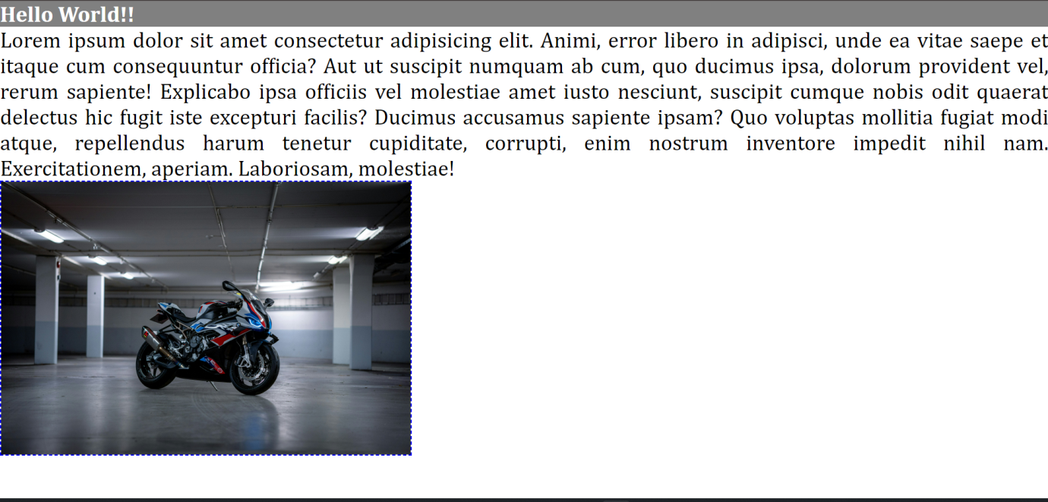

**2.** Design the following template using HTML & CSS. Social media links   
will have different color on mouse hover.

CODE : q2.html

<!-- Name : uttam kumjar jena

Sic : 23mmci80 -->

<!DOCTYPE html>

<html lang="en">

<head>

<meta charset="UTF-8">

<meta name="viewport" content="width=device-width, initial-scale=1.0">

<title>Profile Card</title>

<style>

body {

font-family: Arial, sans-serif;

background-color: rgb(34, 34, 34);

color: #fff;

display: flex;

justify-content: center;

align-items: center;

}

.profile-card {

background-color: rgb(51, 51, 51);

border-radius: 12px;

margin-top: 100px;

padding: 20px;

width: 300px;

height: 500px;

text-align: center;

}

.dp {

height: 150px;

width: 150px;

border-radius: 50%;

}

.name {

font-size: 32px;

margin-top: 10px;

}

.location {

color: lime;

font-size: 14px;

}

.quote {

font-style: italic;

margin-top: 20px;

}

.btn {

margin: 10px;

text-decoration: none;

color: white;

background-color: #444;

padding: 10px 15px;

border-radius: 8px;

display: block;

}

.btn:hover {

color: black;

background-color: limegreen;

}

</style>

</head>

<body>

<div class="profile-card">

<img class="dp" src="prof.jpg" alt="">

<div class="name">Jessica Randall</div>

<div class="location">London, United Kingdom</div>

<div class="quote">"Front-end developer and avid reader."</div>

<a href="" class="btn">GitHub</a>

<a href="" class="btn">Frontend Mentor</a>

<a href="" class="btn">LinkedIn</a>

<a href="" class="btn">Twitter</a>

<a href="" class="btn">Instagram</a>

</div>

</body>

</html>

**OUTPUT:**

**3.** Design the following table. Use HTML table but Do NOT use any table   
attribute. Use external CSS to give exact look.

CODE: q3.html

<!-- Name : uttam kumjar jena

Sic : 23mmci80 -->

<!DOCTYPE html>

<html lang="en">

<head>

<meta charset="UTF-8" />

<meta name="viewport" content="width=device-width, initial-scale=1.0" />

<title>Document</title>

<style>

body {

margin: 0;

padding: 0;

font-family: Arial, sans-serif;

}

table {

width: 60%;

margin: 50px auto;

border-collapse: collapse;

text-align: left;

}

caption {

font-weight: bold;

font-size: 24px;

margin-bottom: 10px;

}

th,

td {

padding: 12px;

border: 1px solid #ddd;

}

thead {

background-color: #333;

color: white;

}

tbody tr:nth-child(even) {

background-color: grey;

}

</style>

</head>

<body>

<table>

<caption>

Student Information

</caption>

<thead>

<tr>

<th>Roll</th>

<th>Name</th>

<th>Mobile</th>

<th>Email</th>

</tr>

</thead>

<tbody>

<tr>

<td>1</td>

<td>Jhon</td>

<td>999999</td>

<td>Jhon@gmial.com</td>

</tr>

<tr>

<td>2</td>

<td>Jane</td>

<td>888888</td>

<td>jane@gmail.com</td>

</tr>

<tr>

<td>3</td>

<td>Sam</td>

<td>777777</td>

<td>sam@gmail.com</td>

</tr>

<tr>

<td>4</td>

<td>Willy</td>

<td>666666</td>

<td>willy@gmai.com</td>

</tr>

<tr>

<td>5</td>

<td>Albart</td>

<td>555555</td>

<td>albart@gmail.com</td>

</tr>

</tbody>

</table>

</body>

</html>

**OUTPUT:**

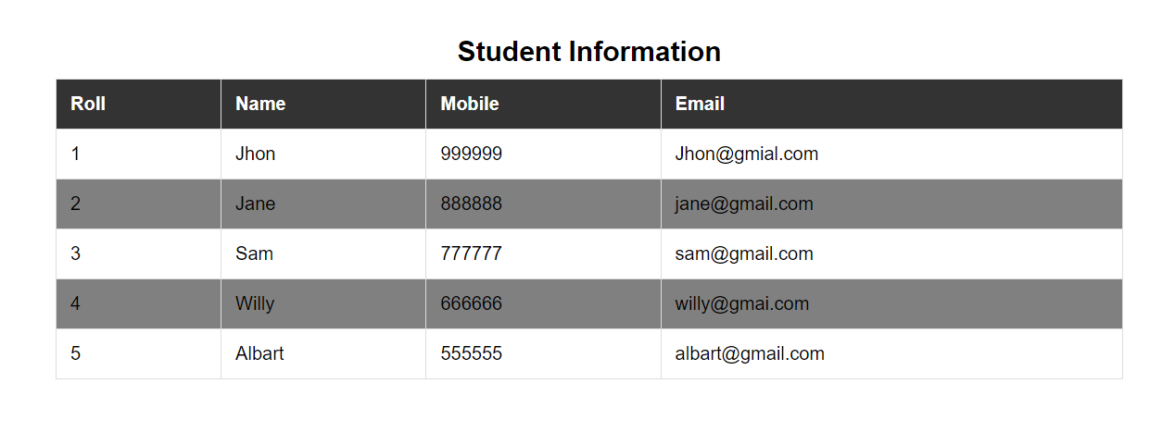

**4.** Design the following form using HTML and External CSS.

**CODE:**

<!-- Name: Uttam Kumar jena

Sic : 23mmci80 -->

<!DOCTYPE html>

<html lang="en">

<head>

<meta charset="UTF-8" />

<meta name="viewport" content="width=device-width, initial-scale=1.0" />

<title>SignIn Form</title>

<link rel="stylesheet" href="q4.css" />

</head>

<body>

<form action="" method="">

<div class="box">

<h1>SignIn</h1>

<label for="username">Username</label>

<input

type="text"

id="username"

placeholder="Username / Email Address"

/>

<label for="password">Password</label>

<input type="password" id="password" placeholder="************" />

<label for="institute">Institute</label>

<select name="institute" id="institute">

<option value="SIT Bhubaneswar">SIT Bhubaneswar</option>

<option value="SIT Sambalpur">SIT Sambalpur</option>

</select>

<div class="checkbox-container">

<input type="checkbox" id="remember" />

<label for="remember">Remember Me</label>

</div>

<input type="submit" value="Log In" />

</div>

</form>

</body>

</html>

**EXTERNAL CSS FILE:q4.css**

* {

margin: 0;

padding: 0;

box-sizing: border-box;

font-family: Arial, sans-serif;

}

body {

display: flex;

justify-content: center;

align-items: center;

height: 100vh;

background-color: rgb(244, 244, 244);

}

.box {

width: 350px;

height: 450px;

border: 1px solid white;

border-radius: 5px;

background-color: #fff;

text-align: left;

}

.box h1 {

height: 50px;

border-bottom: 1px solid black;

text-align: center;

margin-top: 20px;

margin-bottom: 20px;

font-size: 24px;

}

.box label {

font-weight: bold;

margin: 10px 0 5px ;

display: block;

margin-left: 20px;

}

.box input[type="text"], .box input[type="password"], .box select {

width: 90%;

padding: 10px;

margin-left: 20px;

margin-bottom: 15px;

border: 1px solid white;

border-radius: 4px;

}

.checkbox-container {

display: flex;

align-items: center;

margin-bottom: 15px;

}

.checkbox-container input[type="checkbox"] {

margin-right: 10px;

margin-left: 20px;

}

.box input[type="submit"] {

width: 90%;

margin-left: 20px;

padding: 10px;

border: none;

border-radius: 4px;

background-color: rgb(0, 123, 143);;

color: white;

font-size: 16px;

cursor: pointer;

}

.box input[type="submit"]:hover {

background-color: rgb(0,95,107);

}

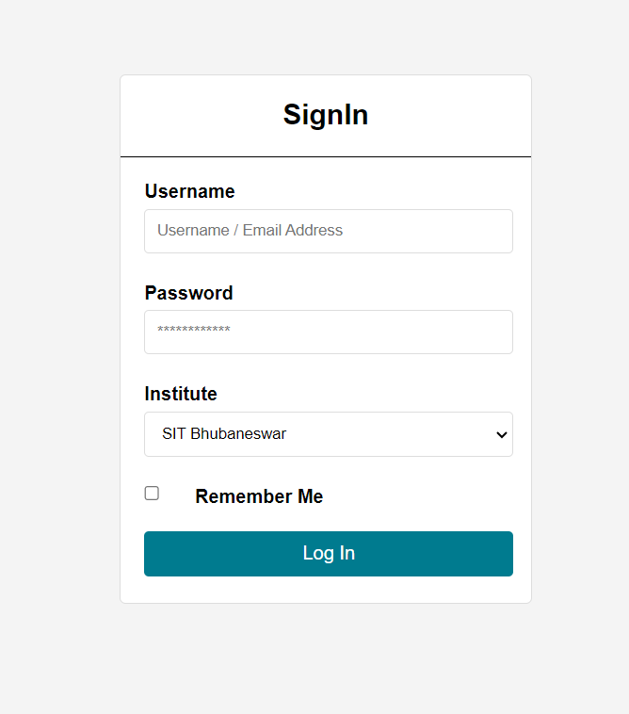**OUTPUT:**